For Immediate Release

Sandhills Development Company Announces a New Industrial Building
in Lexington County Industrial Park

COLUMBIA, S.C. – February 5, 2009 – Sandhills Development Company announces the groundbreaking of Midway Logistics, a new industrial building located in their Lexington County Industrial Park.
Miller-Valentine Group is developing and constructing the 176,400 square-foot multi-tenant building. The tilt-up, hard wall facility is designed to meet the needs of today’s Class “A” industrial tenants, offering space for lease from 16,000 SF and up. JanPak, Inc. will anchor the building in a 50,400 square-foot end cap and utilize this building as a distribution hub for the Midlands region.
“Midway Logistics and Miller Valentine Group bring a level of quality in both building and operations to the park that is unmatched in this area. This building will set the tone for the park and differentiates it from others in the area. Any company looking for quality space or building site will have to look at Lexington County Industrial Park,” said Lloyd Kapp, Project Manager of Lexington County Industrial Park.
The 290-acre master planned industrial park is located on US Highways 21/321 at the crossroads of I-26 and I-77. The park offers its potential tenants a wide range of site options ranging from 2 acres to 100+ acres. Its central location provides excellent access to regional metropolitan areas as well as the Charleston and Savannah seaports. The park qualifies as a Multi-County Industrial Park thereby granting special incentives for qualified occupants.
For more information about opportunities within Lexington County Industrial Park, please contact Derek Mathis at 803.798.3800 or Lloyd Kapp at 803.771.8787.
###

Relevant Photographs
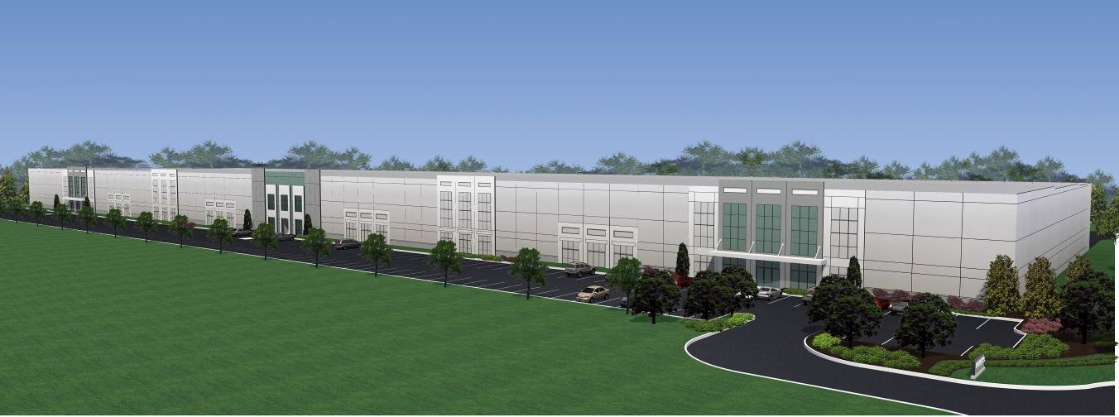

Rendering of Midway Logistics exterior.

